Resources for Baptism in Simple English – Materiaalia kasteisiin yksinkertaisella englannin kielellä  
  
Contents – Sisällys

Baptism of a child – Lapsen kaste 2  
Baptism of an adolescent or adult – Nuoren tai aikuisen kaste 12

Emergency baptism – Hätäkaste 18

Emergency baptism, order A: When the person baptising is a layperson – Hätäkaste A, kun kastajana on joku muu kuin pappi 19

Emergency baptism, order B: When the person baptising is a pastor – Hätäkaste B, kun kastajana on pappi 20

Service of prayer for remembering baptism after an emergency baptism – Kasteen muistamisen rukoushetki sairaalassa toimitetun kasteen jälkeen 24

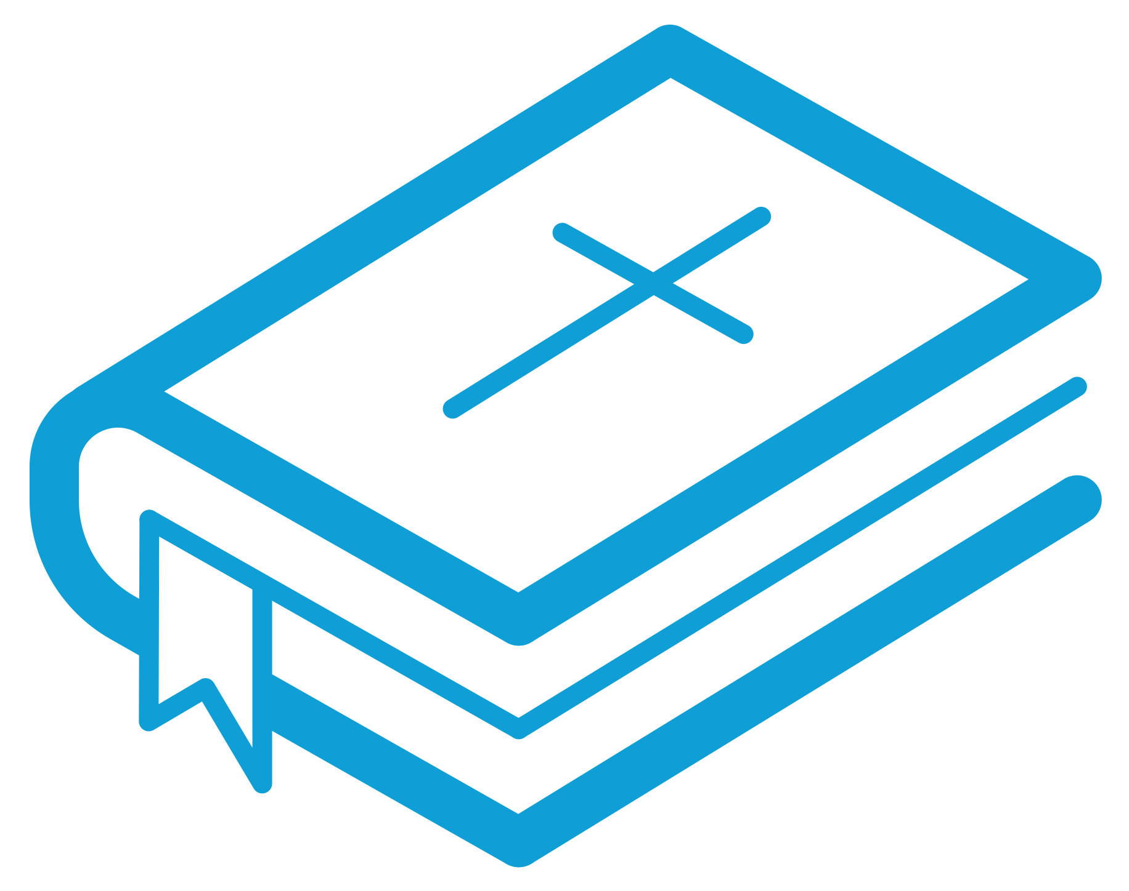en. gla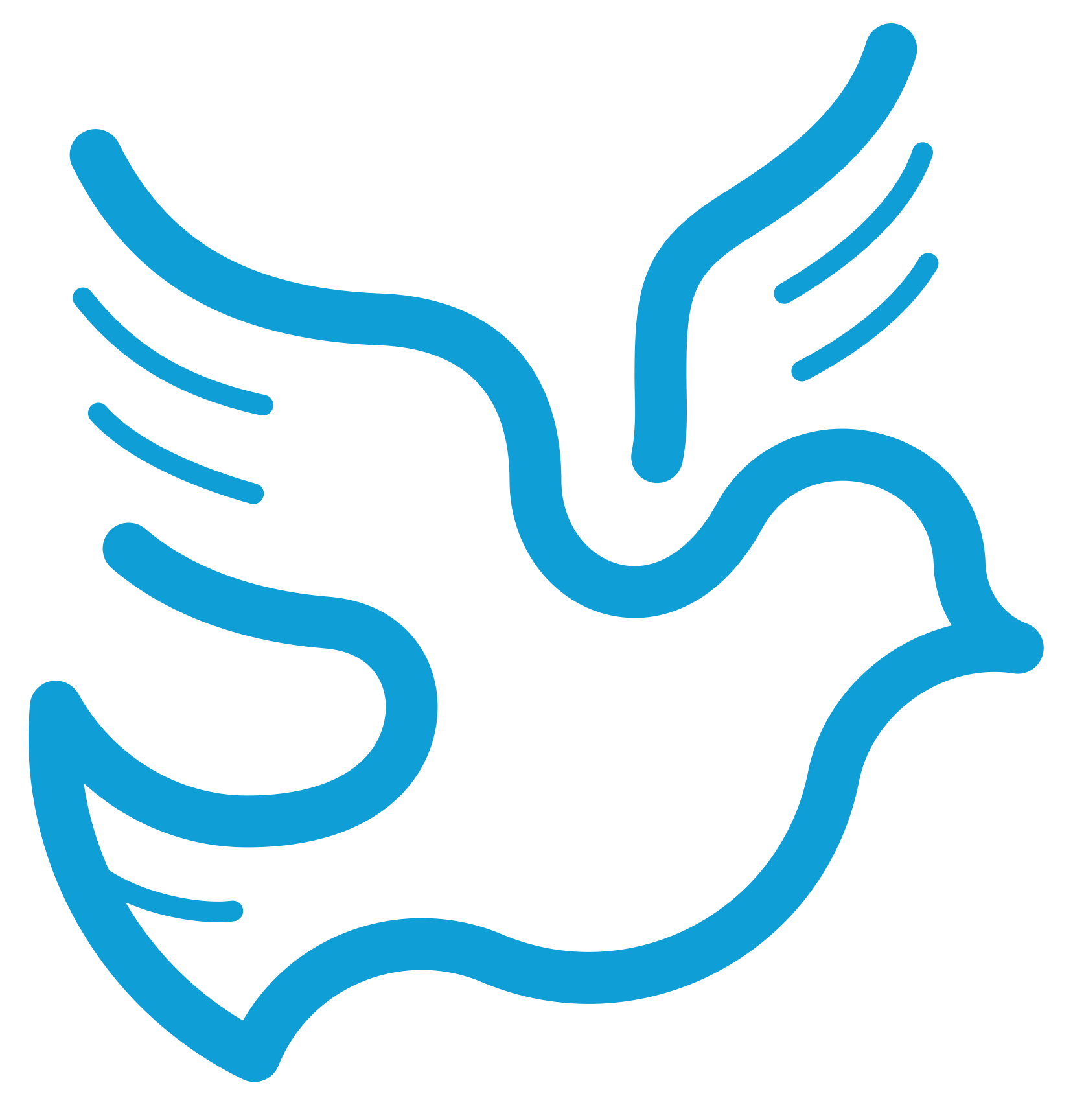 ki

# Resources for Baptism in Simple English – Materiaalia kasteisiin yksinkertaisella englannin kielellä

# Baptism of a child – Lapsen kaste

This order for baptism is usually used for infants and preschoolers. When baptizing older children up to fourteen years of age, consider whether to use this order or the one for the baptism of an adolescent or adult. 

More detailed information about the requirements of the Church Law, the Church Order and the ecumenical agreements on religious affiliation, freedom of religion, and godparents can be found here in Finnish <https://kirkkokasikirja.fi/toim/01a_lapsen_kaste.pdf>

The pastor who will be conducting a baptism must contact the home of the child to be baptized well ahead of time to arrange a face-to-face meeting to discuss the meaning of baptism and the practical arrangements. The pastor is to fill out the official form for registration of baptism and return it to the parish office on the next office day after the baptism. The name of the child may also be registered using this form.  

A baptism is usually conducted in a church, a home or some other location as agreed upon by the pastor and the child’s parents. Water is poured into the font before the service begins or just before the Great Commission (# 11) is read.

An Easter candle may be lit to burn during the entire service. The baptism may be recorded in the family Bible.

P: Pastor

A: All

R: Reader



1 Opening hymn / Virsi  
  
2 Greeting / Alkusiunaus

Invocation

P: In the name of the Father, and of the (B) Son,

and of the Holy Spirit.

A: Amen.

Greeting

Optional

P: The Lord be with you

A: and with your spirit.

3 Introductory words / Johdantosanat  
You may use one of the following texts or your own words.

Dear Christians, we are here because God has given this child to you, NN and NN (parents’ names). You have followed Christ’s command. He/she will be baptized. God calls him/her by his/her name. God gives him/her salvation as a gift.

**OR**

Christians, we have come here today to celebrate Christian baptism. Jesus invited little children to come to him and gave them his blessing. In holy baptism, Jesus takes this child to be his own. Jesus gives him/her the gift of eternal life. Jesus has promised us, saying, “The Father gives me my people. Every one of them will come to me. I will always accept them.” (John 6:37)

**OR**

Dear friends, if you wish to enter the kingdom of heaven, you must be born again by water and the Spirit. Our Lord Jesus Christ has given us baptism as a sign and seal of new life. Baptism washes us clean from sin and clothes us in new life. Jesus says: “I am the gate. Whoever enters through me will be saved. They will be able to come in and go out. They will find everything they need.  A thief comes to steal, kill, and destroy. But I came to give life – life that is full and good.” (John 10:9–10)

4 Psalm / Psalmi    
Optional

5 Questions or invitation / Kysymykset tai kehotus

Questions 1

P: As a parent/the parents, you have chosen a name for this child.

What name have you chosen?

Parent(s): (Name)

P: Do you wish him/her to be baptized into the Christian faith?

Parent(s): I/We do.

P: Parent(s) and godparents, do you, together with the congregation, wish to bring up NN in the Christian faith?

Parent(s): I/We do.

Questions 2

P: As a parent/the parents of this child, you have given him/her the name NN (given names). Do you wish him/her to be baptized into the Christian faith?

Parents

(together): We do.

P:  Parent(s) and godparents, do you, together with the congregation,

wish to bring up NN in the Christian faith?

Parent(s): I/We do.

Or a pronouncement

P: As a parent/the parents of this child, you have given him/her the name NN (given names).

Your child will be baptized today into the Christian faith. As parent(s) and godparents, you are responsible, together with the congregation, for bringing up NN in the Christian faith.

6 Sign of the cross / Ristinmerkki

The pastor says:

Merciful God, you alone save us from the power of sin, death, and evil. Write NN’s name into the book of life. Let your light shine upon him/her and lead him/her into the kingdom of heaven.

While marking the forehead and chest of the child with the sign of the cross, the pastor says:

Receive the sign of the cross on your forehead (+) and chest (+). It is a sign that Jesus Christ has saved you. He has died on the cross and risen from the dead. He has called you to follow him.

**OR**

While marking the forehead and chest of the child with the sign of the cross, the pastor says:

Receive the sign of the cross (+) on your forehead and chest. It is a sign that Jesus Christ has saved you. He died on the cross and has risen from the dead. He has called you to follow him.

The pastor continues:

Merciful God, you alone deliver us

from [the powers of] evil.     
Write NN’s name into the book of life.     
Let your light shine on him/her.

Lead him/her on the way to eternal life.

7 The Collect / Rukous

P: Let us pray.  

1

God, our Father in heaven,

we thank you for the gift of life.

In baptism you give us gifts of grace and love.

This child has been blessed with the sign of the cross.

Take him/her to be your own.

Let the saving work of your Son Jesus Christ

protect him/her from all harm.

Let your Holy Spirit live in this child.

Let him/her grow in faith and love.

Hear us for the sake of Jesus Christ.

2

God, our Father in heaven, you give us life. In baptism you grant us your mercy and love. Receive NN into the family of God. Give him/her your Holy Spirit. Let him/her grow in faith and love. This we pray in the name of Jesus Christ.

3

Almighty God, we thank you for this child. He/she is a gift to us.

We thank you for the future and the hope that you give him/her.

Thank you that the kingdom of heaven belongs to children.

In baptism you take us into your care and into the fellowship of the church.

You guide us with your Holy Spirit and your word.

Let this child enjoy all the gifts of salvation.

Let him/her grow as a disciple of Jesus Christ.

Support him/her with your strength

and keep him/her in the faith unto eternal life.

This we pray in the name of our Lord Jesus Christ.

4

God, our Father in heaven, you are full of grace.

We thank you for the gift of baptism.

It washes away all our sins in Jesus’s name.

A new life with the Holy Spirit begins.

Thank you for all this.

We pray: In baptism take this child to live as your child.

Thank you for setting him/her free from the chains of sin, death and darkness.     
Let him/her serve you as your child throughout his/her life.

Let him/her find a place in heaven after this life.

Hear us for the sake of Jesus Christ.

5

God, our Father:

Life is a gift from you.

We thank you for this gift.

Thank you for holding this child in your care and protection.

Take him/her into your family in baptism.

Make the love of Jesus real to him/her

every step of the way.

Now this child is frail and weak.

Be with him/her and carry him/her in your arms.

Light up his/her whole life.

Hear us for the sake of Jesus Christ.

A: Amen.

8 Readings of the Bible / Raamatunluku

The children’s gospel Mark 10:13-16 is not optional and should always be read at the baptism of a child. Besides the children’s gospel, you may add one or more of the passages suggested here or some other Bible passage.

Mark 10:13–16

People brought their small children to Jesus so that he could lay his hands on them to bless them. But the followers told the people to stop bringing their children to him. Jesus saw what happened. He did not like his followers telling the children not to come. So he said to them, “Let the little children come to me. Don’t stop them, because God’s kingdom belongs to people who are like these little children. The truth is, you must accept God’s kingdom like a little child accepts things, or you will never enter it.” Then Jesus held the children in his arms. He laid his hands on them and blessed them.

Optional passages:

Galatians 3:26–27   
You were all baptized into Christ, and so you were all clothed with Christ. This shows that you are all children of God through faith in Christ Jesus.

Titus 3:4–8   
But then the kindness and love of God our Saviour was made known. He saved us because of his mercy, not because of any good things we did. He saved us through the washing that made us new people. He saved us by making us new through the Holy Spirit. God poured out to us that Holy Spirit fully through Jesus Christ our Saviour. We were made right with God by his grace. God saved us so that we could be his children and look forward to receiving life that never ends. This is a true statement.

1 Peter 3:20–21   
God was waiting patiently for people while Noah was building the big boat. And only a few – eight in all – were saved in the boat through the floodwater. And that water is like baptism, which now saves you. Baptism is not the washing of dirt from the body. It is asking God for a clean conscience. It saves you because Jesus Christ was raised from death.

9 Sermon or speech / Puhe

10 Hymn / Virsi   
Optional

11 The Great Commission / Kastekäsky  
The words of the institution of baptism

P:  Jesus said to his disciples: “All authority in heaven and on earth is given to me. So go and make followers of all people in the world. Baptize them in the name of the Father and the Son and the Holy Spirit. Teach them to obey everything that I have told you to do. You can be sure that I will be with you always. I will continue with you until the end of time.” (Matthew 28:18–20)

**OR**

God, giver of life, you created water to make things grow on the earth, to refresh and to cleanse us. You saved Noah and his family in the ark carried by waters. We thank you for giving us baptism to be our ark of salvation.

Through the waters your people passed, from slavery in Egypt into freedom.

Your son Jesus received baptism in the water of Jordan.

By his death and resurrection, he freed us from the chains of sin and death.

After he had risen from the dead, he himself instituted holy baptism, when he said to his disciples:   
“All authority in heaven and on earth is given to me. So go and make followers of all people in the world. Baptize them in the name of the Father and the Son and the Holy Spirit. Teach them to obey everything that I have told you to do. You can be sure that I will be with you always. I will continue with you until the end of time.”

We pray: give us your Holy Spirit,

so that the one that will be baptized in this water will receive new life.

Let him/her inherit your eternal kingdom.

Hear our prayers for the sake of Jesus Christ our Lord,

inheritor of your eternal kingdom. Hear our prayers for the sake of

Jesus Christ our Lord.

A: Amen.

12 The Creed / Uskontunnustus

P: Let us confess our Christian faith together.

A: I believe in God,

the Father almighty,

creator of heaven and earth.

I believe in Jesus Christ, God's only Son, our Lord,

who was conceived by the Holy Spirit,

born of the Virgin Mary,

suffered under Pontius Pilate,

was crucified, died, and was buried;

he descended to the dead.

On the third day he rose again;

he ascended into heaven.

He is seated at the right hand of the Father,

and he will come to judge the living and the dead.

I believe in the Holy Spirit,

the holy Catholic Church,

the communion of saints,

the forgiveness of sins,

the resurrection of the body,

and life everlasting.

P: Into this faith, this child will be baptized.

13 Baptism / Kaste

The pastor pours water onto the child’s head three times and says:

NN (given names only),

I baptize you in the name

of the Father and of the Son and of the Holy Spirit.

The pastor then lays his/her hand on the child’s head. Parents and godparents may also do so.

P: The grace of our Lord Jesus Christ, the love of God,

and the communion of the Holy Spirit be with you.

A: Amen.

Optional

The pastor takes hold of the child’s baptismal dress and says:

The apostle Paul says, “You were all baptized into Christ, and so you were all clothed with Christ. This shows that you are all children of God through faith in Christ Jesus.” (Gal. 3:27)

Optional  
The pastor takes the baptismal candle and lights it from an altar candle, an Easter candle, or some other candle burning by the font. Then the pastor gives the lit candle to the parent(s) and says: 

Jesus says, “I am the light of the world. Whoever follows me will never walk in darkness but will have the light of life.” (John 8:12)

Optional

The pastor takes the child into his/her arms and says:

In holy baptism, NN (given names) has become a member of Christ’s church and the congregation of X (name of local congregation). We take him/her and his/her home into our love and prayers. Jesus held a child in his arms and said: “Whoever accepts children like these in my name is accepting me. And anyone who accepts me is also accepting the one who sent me.” (Mark 9:37)

P: In holy baptism, NN has been received as a family member of the Church of Christ and X parish. We will pray for NN on his/her life journey.   

The pastor gives the child back to a parent or godparent.

14 Hymn / Virsi     
Optional

15 Prayer of intercession / Yhteinen esirukous

Besides using the prayer given here, it is also possible to prepare (and read) a prayer together with relatives or friends who are coming to the baptism.

P: Let us pray.

Heavenly Father, thank you for the gift of life. You have adopted NN as your own child and a member of X parish. You have given him/her eternal life. Be always his/her shelter and protection.

Father or mother / isä tai äiti

Heavenly Father, we thank you for our beautiful child. God has made him/her beautiful, a wonder to see. We are happy for the joy she/he brings into our lives. We ask you to guard her/him. Grant us much love and wisdom. Guide our family with your love and mercy all our days.

Godparent / joku kummeista

Help us godparents love our goddaughter/godson. We will pray for her/him every day. Show us ways to support her/his parents on their journey together. Give us all a beautiful journey together.

Sister or brother / joku sisaruksista

Heavenly Father, I want to thank you for my little sister/brother. Thank you for the journey that we shared together. Give us times of joy and let us always stay close in our hearts to each other.

Grandparents / joku isovanhemmista

Heavenly Father, thank you for my grandson/daughter's gift of life. She/He is a miracle. Guard us on our way to you and grant us many years together. Let our days be filled with joy, closeness, and tenderness. Protect us with your light on our journey.

P:  Heavenly Father, hear our prayers in Jesus’s name. Into your arms we commend NN, our lives, and the whole world.

A:  Amen

16 The Lord’s Prayer / Isä meidän

Our Father in heaven,

hallowed be your name.

Your kingdom come,

your will be done,

on earth as it is in heaven.

Give us today our daily bread.

Forgive us our sins

as we forgive those who sin against us.

Save us from the time of trial

And deliver us from evil.

For the kingdom, the power, and the glory are yours,

now and forever.

Amen.

17 Blessing / Siunaus

P:  The Lord bless you and keep you;

the Lord make his face shine upon you,

and be gracious to you;

the Lord lift up his countenance upon you,

and give you peace.

In the name of the Father, and of the (+) Son, and of the Holy Spirit.

A:  Amen.

18 Hymn / Virsi

# Baptism of an adolescent or adult – Nuoren tai aikuisen kaste

This order is used when a person fifteen or more years of age is baptized and may, after deliberation, be used for a baptism of a sufficiently mature child under that age. (For legal requirements concerning the religious affiliation of children, see the introduction to the order for baptism of a child.)

Young persons and adults who have not been baptized can join the church after receiving instruction (rippikoulu), after which they can be baptized.

A young person who is at least fifteen but less than eighteen years old can, with written permission from his/her guardians and regardless of their religious affiliation, ask the parson (head pastor, kirkkoherra) of a parish if they can become a member of the Evangelical Lutheran Church of Finland.

The baptismal candidate must have at least two godparents (sponsors) who are confirmed members of a church that has an Evangelical Lutheran confession or a church with which the Evangelical Lutheran Church of Finland has a ratified agreement on this matter. In addition to godparents, a person belonging to a Christian church or community that recognizes the validity of baptism administered in the Evangelical Lutheran church may also be a godparent. At least two godparents or other witnesses must be present at a baptism.

Receiving baptism as a young person or adult also makes that person confirmed. In that case, however, the person has the right to take part in a separate rite of confirmation with others should they wish to do so.

A baptism is conducted in a church, a home or some other suitable place. An Easter candle may be lit for the entire service. When choosing music, it is necessary to remember that a baptism is also an occasion of worship. If possible, the person to be baptized should wear an alb. The alb may be put on before the service or after the act of baptism (#13).

The prayers and words from the ordo of the baptism of a child may also be used. The baptismal candidate may take part in choosing Bible passages and prayers to be read/used at this service.

P: Pastor

A: All

R: Reader



1 Hymn / Virsi

2 Blessing and greeting / Siunaus ja tervehdys

**Invocation**

P: In the name of the Father, and of the (B) Son, and of the Holy Spirit.

A: Amen.

**Greeting**

Optional

P: The Lord be with you

A: and with your spirit.

3 Introductory words / Johdantosanat   
  
4 Psalm / Psalmi   
Optional

5 Sign of the Cross / Ristinmerkki

The pastor says:

Merciful God, you alone save us from the power of sin, death, and evil. Write NN’s name into the book of life. Let your light shine upon him/her and lead him/her into the kingdom of heaven.

While marking the forehead and chest of the child with the sign of the cross, the pastor says:

Receive the sign of the cross on your forehead (+) and chest (+). It is a sign that Jesus Christ has saved you. He has died on the cross and risen from the dead. He has called you to follow him.

**OR**

While marking the forehead and chest of the child with the sign of the cross, the pastor says:

Receive the sign of the cross (+) on your forehead and chest. It is a sign that Jesus Christ has saved you. He died on the cross and has risen from the dead. He has called you to follow him.

The pastor continues:

Merciful God, you alone deliver us

from [the powers of] evil.     
Write NN’s name into the book of life.     
Let your light shine on him/her.

Lead him/her on the way to eternal life.

**6 The Collect / Kollehtarukous**

P: Heavenly Father,

we thank you for the life you give us.

In baptism we receive a new life in Christ.

NN has now been blessed with the sign of the cross.

Keep him/her/them as your own.

Let your Holy Spirit guide him/her/them.

Help NN grow in faith and love,

in the name of Jesus.

A: Amen

**7 Bible reading / Raamatunluku**

Use one of the following or other Bible passages.

Galatians 3:26–27   
You were all baptized into Christ, and so you were all clothed with Christ. This shows that you are all children of God through faith in Christ Jesus. 

Titus 3:4–8   
But then the kindness and love of God our Saviour was made known. He saved us because of his mercy, not because of any good things we did. He saved us through the washing that made us new people. He saved us by making us new through the Holy Spirit. God poured out to us that Holy Spirit fully through Jesus Christ our Saviour. We were made right with God by his grace. God saved us so that we could be his children and look forward to receiving life that never ends. This is a true statement.

1 Peter 3:20–21   
God was waiting patiently for people while Noah was building the big boat. And only a few – eight in all – were saved in the boat through the floodwater. And that water is like baptism, which now saves you. Baptism is not the washing of dirt from the body. It is asking God for a clean conscience. It saves you because Jesus Christ was raised from death.

8 Short sermon or speech / Puhe   
  
9 Hymn / Virsi

Optional

10 The Great Commission / Kastekäsky

(Words of the institution of baptism)

P:  Jesus said to his disciples, “All authority in heaven and on earth is given to me. So go and make followers of all people in the world. Baptize them in the name of the Father and the Son and the Holy Spirit. Teach them to obey everything that I have told you to do. You can be sure that I will be with you always. I will continue with you until the end of time.” (Matthew 28:18–20)

11 The Creed / Uskontunnustus

P: Let us confess our Christian faith together.

A: I believe in God,

the Father almighty,

creator of heaven and earth.

I believe in Jesus Christ, God's only Son, our Lord,

who was conceived by the Holy Spirit,

born of the Virgin Mary,

suffered under Pontius Pilate,

was crucified, died, and was buried;

he descended to the dead.

On the third day he rose again;

he ascended into heaven.

He is seated at the right hand of the Father,

and he will come to judge the living and the dead.

I believe in the Holy Spirit,

the holy Catholic Church,

the communion of saints,

the forgiveness of sins,

the resurrection of the body,

and the life everlasting.

12 The Question / Kysymys

P: Do you wish to be baptized into this faith?

Baptismal candidate: Yes

13 Baptism / Kaste  

P: We now baptize you in the name of the Father, and of the Son,

and of the Holy Spirit. 

The pastor pours water three times onto the head of the person being baptized and says:

NN (given names only), I baptize you in the nameof the Father and of the Son and of   
the Holy Spirit.

The pastor then lays his/her hand on the head of the baptized one. Godparents [and parents]   
may also do so.

The grace of our Lord Jesus Christ, the love of God, and the communion of the   
Holy Spirit be with you.

The baptized person responds:

Amen.

Optional

If the newly baptized person is not already wearing an alb, his/her/their godparents now put one on him/her/them. The pastor says:

The apostle Paul says, “As many of you as were baptized into Christ have clothed yourselves with Christ.” (Gal. 3:27)

Optional

The pastor takes the baptismal candle and lights it from an altar candle, an Easter candle or a candle burning by the font. Then the pastor gives the lit candle to the newly baptized person and says:

Jesus says, “I am the light of the world. Whoever follows me will never walk in darkness but will have the light of life.” (John 8:12)

P: In holy baptism you have become a member of Christ’s church

and the parish of X (name of local congregation).

We take you into our prayers.

The apostle Paul said, “So then, you are no longer foreigners and strangers, but you are fellow citizens with the saints and members of God's household”. (Eph. 2:19)

14 Hymn / Virsi

Optional

15 Intercession / Yhteinen esirukous

You may pray with your own words.

P: Let us pray

God, our loving Father,

we thank you for welcoming NN into your family.

Let your Holy Spirit strengthen him/her/them in his/her/their life as he/she/they find his/her/their way.

Bless the godparents and help them support NN.

Let us all know your love and goodness all our days.

Keep us all in your care and give us hope for the future.

Lord, hear our prayer.

A: Amen.

16 Lord’s prayer / Isä meidän

Our Father in heaven,

hallowed be your name.

Your kingdom come,

your will be done,

on earth as it is in heaven.

Give us today our daily bread.

Forgive us our sins

as we forgive those who sin against us.

Save us from the time of trial

and deliver us from evil.

For the kingdom, the power, and the glory are yours

now and forever.

Amen

17. Blessing / Siunaus

P:  The Lord bless you and keep you;

the Lord make his face shine upon you,

and be gracious to you:

The Lord lift up his countenance upon you,

and give you peace.

In the name of the Father, and of the + Son, and of the Holy Spirit.

A:  Amen

18 Hymn / Virsi

# Emergency babtism – Hätäkaste

If it is feared that an unbaptized child may die, and a pastor is not immediately available to administer baptism, any member of the Lutheran church or another Christian can baptize the child with water in the name of the triune God. The parish office must be notified immediately after the baptism. Later, if the child survives, a special service of prayer, blessing and commemorating the baptism will be held.

This order is also followed if it is necessary to baptize an unbaptized adult and there is no time to wait for a pastor. If possible, there should be witnesses present at an emergency baptism. A hymn may be sung at the ceremony.

P: Pastor

A: All

R: Reader



# Emergerncy baptism order A: When the person baptising is a layperson – Hätäkaste B, kun kastava henkilö ei ole pappi

1 Baptism / Kaste

The person performing the baptism pours water three times onto the head of the person being baptized and says:

[NN (given names only, if any),]    
I baptize you in the name of the Father and of the Son and of the Holy Spirit.

2 Lord’s Prayer / Isä meidän

All Christians who are able to join the prayer say the prayer together. Each person may pray in their own language.

Let us pray together.

Our Father in heaven,

hallowed be your name.

Your kingdom come,

your will be done,

on earth as it is in heaven.

Give us today our daily bread.

Forgive us our sins

as we forgive those who sin against us.

Lead us not into temptation

but deliver us from evil.

For the kingdom, the power, and the glory are yours,

now and forever.

Amen.

3 Blessing / Siunaus

The one who administered the baptism says:

P: The Lord bless us and keep us;

the Lord make his face shine upon us,

and be gracious to us.

The Lord lift up his countenance upon us,

and give us peace.

In the name of the Father, and of the (B) Son, and of the Holy Spirit.

A: Amen.

# Emergency baptism, order B: When the person baptising is a pastor – Hätäkaste B, kun kastajana on pappi

Some parts are marked as optional. You may include them if it is possible. When this order is used for baptism the reaffirmation of emergency baptism will not be needed. Instead there may a service of thanksgiving and remembering baptism.

P: Pastor

A: All

R: Reader

Hymn / Virsi

Optional

2 Short introduction / Johdanto

Optional  

P: In the name of the Father, and the Son, and the Holy Spirit.

A: Amen. 

P: We are here to baptize this child/NN and surround him/her in God’s blessing. We pray for NN/him/her, for his/her [parents, sisters and brothers, and for all who are taking care of him/her].

3 Psalm / Psalmi  
Optional. Some verses of Psalm 139 may be read.

4 Sign of the Cross / Ristinmerkki

You may use option 1 or 2 or a pronouncement.

Option 1: Questions / Kysymys  
  
P: As a parent/the parents, you have chosen a name for this child.

What name have you chosen?

Parent(s): (answer)

P: Do you wish him/her to be baptized into the Christian faith?

Parent(s): I/We do.

P:  Parent(s) and godparents, do you, together with the congregation, wish to bring up NN in the Christian faith?

Parent(s): I/We do.

**Option 2: Questions / Kysymys**

P:  As a parent/the parents of this child, you have given him/her the name NN (given names). Do you wish to have him/her baptized into the Christian faith?

Parent(s): I/We do.

P:  Parent(s) and godparents, do you, together with the congregation, wish to bring up NN in the Christian faith?

Parent(s): I/We do.

**Option 3: Pronouncement / Kehotus**

P:  As a parent/the parents of this child, you have given him/her the name NN (given names). Your child will be baptized today into the Christian faith.

As a parent/the parents and godparents, you are responsible, together with the congregation, for bringing up NN in the Christian faith.

4 Children’s Gospel / Lasten evankeliumi

People brought their small children to Jesus so that he could lay his hands on them to bless them. But the followers told the people to stop bringing their children to him. Jesus saw what happened. He did not like his followers telling the children not to come. So he said to them, “Let the little children come to me. Don’t stop them, because God’s kingdom belongs to people who are like these little children. The truth is, you must accept God’s kingdom like a little child accepts things, or you will never enter it.” Then Jesus held the children in his arms. He laid his hands on them and blessed them. (Mark 10:13–16)

5 Baptism / Kaste

The pastor pours water three times onto the head of the person being baptized and says:

[NN (given names, if any),]    
I baptize you in the name   
of the Father, and of the Son, and of the Holy Spirit.

The pastor continues:

As Jesus took children in His arms and blessed them,    
we now ask God’s blessing upon NN/this child.  

The grace of our Lord Jesus Christ,    
The love of God and    
the communion of the Holy Spirit be with you.

A baptismal candle may be given to the parents.

The light of this candle shines for NN/this child.

Jesus says, “I am the light of the world. Whoever follows me will never walk in darkness but will have the light of life.” (John 8:12)

6 Prayer / Rukous

P: Let us pray.

Heavenly Father,

we thank you for the gift of baptism.

You care for every one of us.

Be our strength when we are insecure and in distress.

Surround NN/this child with the warmth of your love.

Protect him/her from any harm.

Send your angels to guard him/her.

Bless everyone who takes care of NN/this child

with your patience and understanding.

Hear our prayer.

A: Amen.

7 Lord’s prayer / Isä meidän

Our Father in heaven,   
hallowed be your name.

Your kingdom come,

your will be done,

on earth as it is in heaven.

Give us today our daily bread.

Forgive us our sins

as we forgive those who sin against us.

Lead us not into temptation

but deliver us from evil.

For the kingdom, the power,

and the glory are yours,

now and forever.

Amen.

8 Blessing / Siunaus

P: The Lord bless you and keep you.

The Lord make his face shine upon you,

and be gracious to you.

The Lord lift up his countenance upon you,

and give you peace.

In the name of the Father,

and the Son, and the Holy Spirit.

A: Amen.

**OR**

The Lord bless us and watch over us;

the Lord make his face shine upon us

and be gracious to us.

The Lord look kindly upon us,

and give us peace.

In the name of the Father, and of the (+) Son, and of the Holy Spirit.

A: Amen.

**OR**

May almighty God,   
Father, (+) Son, and Holy Spirit,  
bless us now and forever.  Amen.

# Service of prayer for remembering baptism after an emergency baptism – Kasteen muistamisen rukoushetki sairaalassa toimitetun kasteen jälkeen

When a child has been baptized by a lay Christian in an emergency and he/she survives, the baptism is ceremonially verified (without water) following the order given below. This happens very rarely, since a hospital chaplain is almost always available at the hospital and will officiate at the baptism. An emergency baptism in the hospital is a real and full baptism that does not need verifying. The family may want to have a ceremony at home using the service of baptismal commemoration.

P: Pastor

A: All

R: Reader



1 Hymn / Virsi    
  
2 Greeting / Tervehdys

P: In the name of the Father, and of the (+) Son, and of the Holy Spirit.

A: Amen.

Optional

P:  The Lord be with you

A:  And with your spirit.

3 Introductory words / Johdantosanat

The pastor speaks in his/her own words or uses one of the alternatives below.

P:   Dear Christians, life is a great gift of God. God has taken this child into His family. In holy baptism, He has given him/her eternal life. We bring this child before God with thanksgiving and pray for God’s blessing.

**OR**

P:   Dear Christians, Jesus invited little children to come close to him and blessed them. In holy baptism, Jesus has taken this child into his loving care and given him/her the gift of salvation. Jesus is our Saviour. We trust in his eternal love and pray for you, (name/names of parent/parents) and your child. Jesus says, “I am with you always, to the end of the age.” (Matthew 28:20)

4 Psalm / Psalmi   
Optional

5 Questions or a pronouncement / Kysymykset tai kehotus

Questions / Kysymykset

P: Parent(s), what name have you given your child?

Parent(s):  NN (given names).

P: NN has been baptized. The Church welcomes him/her with joy. Parent(s) (or name/names of parent/parents) and godparents, do you wish to guide NN in the Christian faith together with the church of Christ?

Parent(s) and

godparents: Yes.

**OR**

P: Parent(s) (or name/names of parent/parents), you have named your child NN (given names). Your child has been baptized and is now a member of the church. Parent(s) and godparents, do you wish to guide NN in the Christian faith together with the church of Christ?

Parent(s)

and/or

godparents: Yes.

Pronouncement / Kehotus

P: Parent(s) (or name/names of parent/parents), you have named your child NN (given names). Your child has been baptized and is now a member of the church. Parent(s) and godparents, guide NN in the Christian faith together with the church of Christ.

6 Sign of the cross / Ristinmerkki   
While marking the forehead and chest of the child with signs of the cross, the pastor says:

Receive the sign of the cross (+) on your forehead and chest.

It is a sign that Jesus Christ has saved you.

He has died on the cross and risen from the dead.

He has called you to follow him.

The pastor continues:

Merciful God, you alone deliver us from [the powers of] evil.     
Write NN’s name into the book of life.     
Let your light shine on him/her and lead him/her on the way to eternal life.

7 The Collect / Rukous  
You may also use prayers from the order for baptism.

P: Let us pray.

1

God, our Father in heaven,

we thank you for the gift of life.

In baptism you give us gifts of grace and love.

This child has been blessed with the sign of the cross.

You have taken him/her to be your own child.

Let the saving work of your Son Jesus Christ

give him/her safety.

Let your Holy Spirit live in this child.

Let him/her grow in faith and love.

Hear us for the sake of Jesus Christ.

2

Almighty God, we thank you for this child. He/she is a gift to us.

We thank you for the future and the hope that you give him/her.

Thank you that the kingdom of heaven belongs to children.

In baptism you take us into your care and into the fellowship of the church.

You guide us with your Holy Spirit and your word.

Let this child enjoy all the gifts of salvation.

Let him/her grow as a disciple of Jesus Christ.

Support him/her with your strength

and keep him/her in the faith until eternal life.

This we pray in the name of our Lord Jesus Christ.

  3

God, our Father in heaven, you are full of grace.

We thank you for the gift of baptism.

It washes away all our sins in Jesus’s name.

A new life with the Holy Spirit begins.

Thank you for all this.

We pray: In baptism take this child to live as your child.

Thank you for the freedom from the chains of sin, death and darkness.     
Let him/her serve you as your child throughout his/her life.

Let him/her find a place in heaven after this life.

Hear us for the sake of Jesus Christ.

A: Amen.

8 Sripture reading / Raamatunluku

The children’s gospel is always read, but you may also use other passages from the Bible.   
   
People brought their small children to Jesus so that he could lay his hands on them to bless them. But the followers told the people to stop bringing their children to him. Jesus saw what happened. He did not like his followers telling the children not to come. So he said to them, “Let the little children come to me. Don’t stop them, because God’s kingdom belongs to people who are like these little children. The truth is, you must accept God’s kingdom like a little child accepts things, or you will never enter it.” Then Jesus held the children in his arms. He laid his hands on them and blessed them. (Mark 10:13–16)

9 Short sermon or speech / Puhe  
  
10 Hymn / Virsi   
Optional  
  
11 The Great Commission / Kastekäsky

Our Lord Jesus Christ himself said to his disciples, “All authority in heaven and on earth is given to me. So go and make followers of all people in the world. Baptize them in the name of the Father and the Son and the Holy Spirit. Teach them to obey everything that I have told you to do. You can be sure that I will be with you always. I will continue with you until the end of time” (Matthew 28:18–20)

**OR**

God, giver of life. Your created water to make things grow on the earth, to refresh and to cleanse us. You saved Noa and his family in the ark carried by waters. We thank you for giving us baptism to be our ark of salvation.

Your people went from slavery in Egypt through the water into freedom.

Your son Jesus received baptism in the water of Jordan. By his death and resurrection he freed us from the chains of sin and death. After he had risen from the dead he himself instituted the holy baptism when he said to his disciples:

“All authority in heaven and on earth is given to me. So go and make followers of all people in the world. Baptize them in the name of the Father and the Son and the Holy Spirit. Teach them to obey everything that I have told you to do. You can be sure that I will be with you always. I will continue with you until the end of time.” (Matthew 28:18–20)

We pray: give us you Holy Spirit, so that the one that will be baptized in this water will receive new life. Let him/her inherit your eternal kingdom.

Hear our prayers for the sake of Jesus Christ our Lord, inheritor of your eternal kingdom. Hear our prayers for the sake of Jesus Christ our Lord.

A: Amen.

12 Uskontunnustus / Creed  

P:  Let us confess our Christian faith together.

A: I believe in God, the Father almighty,

creator of heaven and earth.

I believe in Jesus Christ, God's only Son, our Lord,

who was conceived by the Holy Spirit,

born of the Virgin Mary,

suffered under Pontius Pilate,

was crucified, died, and was buried;

he descended to the dead.

On the third day he rose again;

he ascended into heaven.

He is seated at the right hand of the Father,

and he will come to judge the living and the dead.

I believe in the Holy Spirit,

the holy Catholic Church,

the communion of saints,

the forgiveness of sins,

the resurrection of the body,

and the life everlasting.

13 Declaration / Vahvistussanat

P: This child (name) was baptized in a hospital. It was done as Christ commanded his followers to do with water in the name of the Father and of the Son and of the Holy Spirit.

The pastor then lays his/her hand on the child’s head. Parents and godparents may also do so.

P: Now we bless this child.

The grace of our Lord Jesus Christ,    
the love of God,   
and the communion of the Holy Spirit be with you.

A: Amen.

Optional

The pastor takes the baptism candle and lights it from an altar candle or an Easter candle or some candle burning by the font. Then the pastor gives the lit candle to the parent(s) and says:

“Jesus says, “I am the light of the world. Whoever follows me will never walk in darkness but will have the light of life.” (John 8:12)

The pastor takes the child into his/her arms and says:

In holy baptism NN has become a member of Christ’s church and the congregation of X (name of local congregation). We welcome NN into our community and hold him/her and his/her family in our love and prayers. Jesus took a child in his arms and said, “Whoever welcomes one such child in my name welcomes me.” (Mark 9:37)

The pastor gives the child back to a parent or godparent.

**Commemorating baptism (optional) / Kasteen muistaminen**

P: We Christians are called to remember our baptism. It is a source of faith, grace and love for us. You may dip your fingers in this water and make the sign of cross on your forehead. Parents, you can make the sign of cross on your children, if you wish.

14 Hymn / Virsi   
Optional

15 Prayer of intercession / Esirukous

A prayer prepared beforehand with those participating in the service may be read instead of one of the prayers given here. You may also use prayers from the order for baptism.

P: Let us pray.

1

Heavenly Father, thank you for making NN (child’s name)

a member of your family.    
We pray: let him/her know your protection in his/her life.    
We thank you for all the goodness you have shown to his/her family/parents.    
Bless them with your gifts of love, wisdom and faith.    
Help the godparents to support NN as he/she grows.   
Lead our lives and let us finally enter your glory to be with you.    
Hear us for the sake of your Son Jesus Christ our Lord.  

2

God our Father, thank you for the gift of (child’s name) to

(parent’s/parents’ name/names).    
Thank you for taking him/her in baptism to be your own,    
member of church and an heir of eternal life.    
Bless NN and send your holy angels to protect him/her.    
Help his/her mother and father, grandparents and godparents    
to love and guide him/her throughout life.    
Help him/her walk your path and know your goodness all the days of his/her life.    
Hear our prayers for the sake of your Son Jesus Christ.  

3

Eternal God, you are the source of life.    
We thank you for the goodness you have shown this family.    
Surround the parents with your strength and love as they raise their child.    
In baptism you took NN (the child’s name) as your own.   
Stay close to him/her and let your grace keep him/her safe in life.    
Protect him/her from harm every day.    
Bless NN’s family, godparents and grandparents, and everyone who loves him/her.    
Help them to support each other.    
After this life is over, give us eternal life in a home in heaven.    
Hear our prayers.

A: Amen.

16 Lord’s prayer / Isä meidän

Our Father in heaven,

hallowed be your name.

Your kingdom come,

your will be done,

on earth as it is in heaven.

Give us today our daily bread.

Forgive us our sins

as we forgive those who sin against us.

Save us from the time of trial

and deliver us from evil.

For the kingdom, the power, and the glory are yours,

now and forever.

Amen.

17 Benediction / Siunaus

P: The Lord bless you and keep you.

The Lord make his face shine upon you,

and be gracious to you.

The Lord lift up his countenance upon you,

and give you peace.

In the name of the Father,

and of the Son, and of the Holy Spirit.

A: Amen.

18 Hymn / Virsi   
Optional